Revenue Optimization Analysis
Luke Mallory

The goal of this experiment was to build a model that algorithmically finds the optimal price that maximizes expected profit per consumer. In doing so, there is a tradeoff that occurs between price and sales; while higher prices generate more revenue per sale, this comes at the price of total sales, as consumers will be less inclined to purchase something that is more expensive. This experiment used a combination of a sales function to simulate consumer behavior, grid search and gradient ascent, to estimate the optimal price. It is also important to note that the number of customers used in the experiment is an important measure to track. When more customers are used to estimate the optimal price, they may not be purchasing at the optimal price. In order to obtain the most revenue, keeping the number of customers used to find the optimal price relatively low, while also using enough to provide a substantive estimate was the main objective.
To reach an initial estimate of where the optimal price was located, a list of prices $0-70 in increments of $5 was created. Using grid search, the average revenue for a group of 100 customers was estimated with the sales function. The number of customers and total revenue was also tracked for later use. After finding the averages for every price in the range, the price with the highest value was used as the starting point for the gradient ascent. The gradient ascent was then repeated 30 times on a sample of 100 customers at prices $1 above and below the current price to estimate the revenue maximizing price. Because these prices had many local maxima, the grid search was used to identify a promising region in the range based on the sample, and the gradient ascent was used to narrow down the estimate for the optimal price in this region.
An important aspect of the experiment was accounting for uncertainty among maximum estimated revenues. The sales function effectively simulates uncertainty in consumer behavior, as random sampling is used to generate purchases and revenue values for each potential price. While the average number of customers was 100, the actual number varied based on the randomly generated customer counts. The random sampling can also lead to variation in revenue estimations between iterations. To make the experiment reproducible, a fixed seed of 100 was used during the initial price optimization, and multiple other seeds were used to evaluate the sensitivity of the algorithm. Increasing the number of samples is an effective method to reduce the variation in estimated revenues, but it is also important to monitor the number of customers in each version of the model, as using too many customers can reduce profits overall.
A particular challenge that arose with the experiment was from the randomness of the sampling. In the original model, the grid search found the maximum revenue to be around $50, but when the percentage of optimal revenue was calculated, this value found with gradient descent starting at $50 only captured 58% of the optimal revenue. The price of $50 represented an area with a local maximum in the function, but not a global maximum. To find the area with the global maximum, the experiment was increased to 300 customers to reduce the variation in the sample overall. With 300 customers, the grid search found that the revenue maximizing price was near $25 and captured 76.35% of optimal revenue after gradient ascent. This algorithm was repeated multiple times with other seeds and the results were consistent.

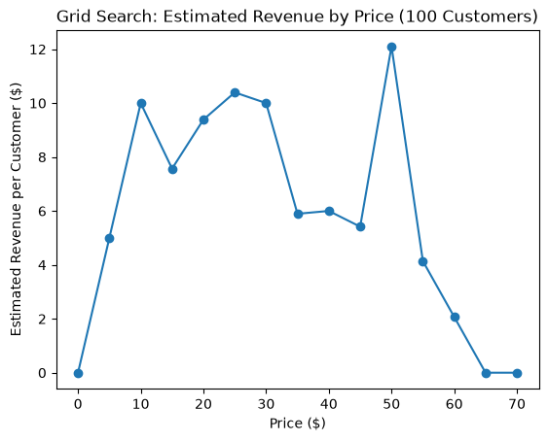 | 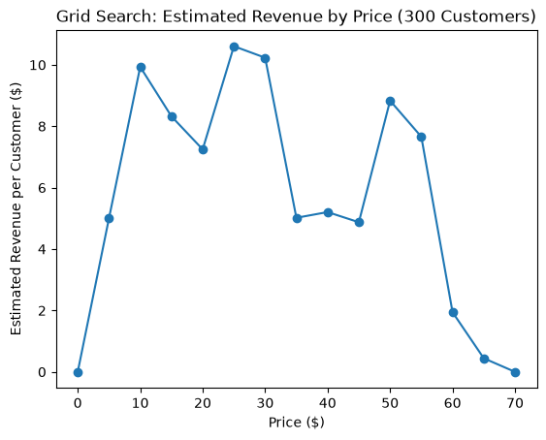

Another issue faced during the experiment was managing the number of customers used in the experiment. While using the maximum number of customers would be the most reliable way of finding the revenue maximizing price, using a large number of customers can reduce profits when they are not purchasing at the optimal price. To manage this tradeoff, the number of customers used to find the optimal price was experimented with. In the first version of the algorithm, an average of 100 customers were sampled, and after 30 gradient descent, 7,547 customers were used in total. In the second experiment, 300 customers were used to control variation in the sampling. As a result, 10,459 customers were sampled after gradient descent, 2,912 more than in the original model. However, the percentage of optimal revenue per customer for the second model is 17.8% stronger than the first. A third model based off the second was tested, featuring 15 gradient ascent repetitions as opposed to 30. This model decreased the number of customers used to 7,540, but the percentage of optimal revenue dropped to 67.44. While it is important to limit the number of customers, based on these results, it appears that around 10,000 customers is necessary to produce the most reliable results.
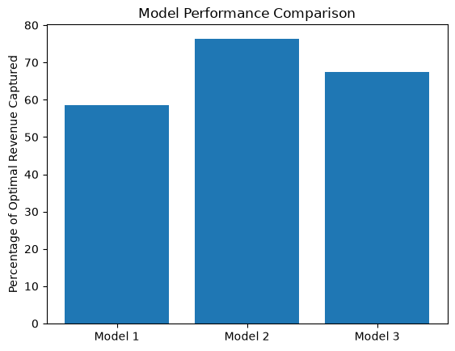
Ultimately, the second model produced the most optimal result. This model found the optimal price to be $28.11, which produced a total experiment revenue of 95222.99, and a percentage of optimal revenue per customer of 76.35%. Using 30 repetitions, 5,987 customers were used during the gradient ascent phase for a total of 10,459 customers overall.

